
RAMAIAH
Institute of Technology
USN | 1 | M | S

(Autonomous Institute, Affiliated to VTU)
(Approved by AICTE, New Delhi & Govt. of Karnataka) Accredited by NBA & NAAC with ‘A’ Grade

MAKEUP EXAMINATIONS – JULY 2019

Course & Branch | : | B.E.: Information Science and Engineering | Semester | : | IV
Subject | : | Design and Analysis of Algorithms | Max. Marks | : | 100
Subject Code | : | IS44 | Duration | : | 3 Hrs

Instructions to the Candidates:
- Answer one full question from each unit.

 |  | UNIT- I
1. | a) | Write an algorithm to solve tower of hanoi problem. Analyze its time efficiency. | CO2 | (07)
 | b) | Algorithm Enigma (A[0….n-1, 0….n-1])  for i←0 to n-2 do  for j← i+1 to n-1 do  if A[i,j] A[j,i]  return false  end for  end for  return true  end algorithm  - What does this algorithm compute?  - What is its input size?  - What is its basic operation?  - How many times is the basic operation executed?  - What is the efficiency class of this algorithm? | CO3 | (08)
 | c) | List some of the most frequently encountered functions in the analysis of algorithms and arrange them in the order of growth. | CO1 | (05)
2. | a) | For each of the following algorithms, indicate (i) a natural size metric for the inputs (ii) its basic operation (iii) whether the basic operation count can be different for inputs of the same size  - Computing the sum of n numbers  - Computing n!  - Finding the largest element in a list of n numbers  - Euclid’s algorithm | CO1 | (08)
 | b) | Identify and define the asymptotic notations used to analyze an algorithm in the best, worst and an average case. Explain each with suitable graphs. | CO3 | (06)
 | c) | One can check whether all elements of an array are distinct by a two-part algorithm based on the array’s presorting. Give the algorithm to search for uniqueness of the presorted array. If the presorting is done by an algorithm with the time efficiency in Θ(nlogn), what will be the time efficiency class of the entire algorithm. | CO2 | (06)
 |  | UNIT– II
3. | a) | Apply the Horspool algorithm to search for the pattern BARBER in the text JIM_SAW_ME_IN_A_BARBERSHOP. Indicate the applicable cases during the pattern shifting. | CO4 | (10)
 | b) | Design a recursive algorithm for Merge sort and analyze the efficiency of Merge sort for worst case time complexity using backward substitution method and also by applying Master’s Theorem. | CO2 | (10)
4. | a) | Apply quicksort to sort the list 5,3,1,7,9,8,2,4 and analyze the best case time complexity by applying Master’s Theorem. | CO3 | (10)
 | b) | Design a Binary search algorithm and find the number of key comparisons in the worst case. Setup and solve the recurrence relation. | CO2 | (10)
 |  | UNIT- III
5. | a) | Write an algorithm to solve all pairs shortest path problem of a directed graph, Solve the all pairs shortest path problem for the digraph with the following weights,  - 2 ∞ 1 8  6 0 3 2 ∞  ∞ ∞ 0 4 ∞  ∞ ∞ 2 0 3  3 ∞ ∞ ∞ 0 | CO2 | (08)
 | b) | Define Minimum spanning tree. Apply Prim’s algorithm to the following graph to find a minimum spanning tree,  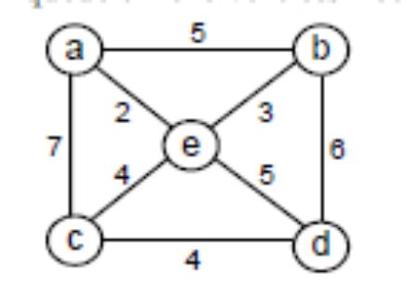 | CO1 | (06)
 | c) | Explain what adjustments if any need to be made in Dijkstra’s algorithm And/or in an underlying graph to solve the following problems.  - Solve the single-source shortest-paths problem for directed weighted Graphs.  - Find a shortest path between two given vertices of a weighted graph or Digraph. (This variation is called the single-pair shortest-path problem.)  iii) Find the shortest paths to a given vertex from each other vertex of a weighted graph or digraph. (This variation is called the single destination shortest-paths problem.) | CO1 | (06)
6. | a) | Write an algorithm to compute the transitive closure of a directed graph. Give an example of a graph or a digraph with negative weights for which Floyd’s algorithm does not yield the correct result. | CO1 | (06)
 | b) | i) Apply the bottom-up dynamic programming algorithm to the following instance of the knapsack problem:  weight {3,2,1,4,5}  Value {$25, $20,$15,$40,$50}, capacity W=6.  ii) How many different optimal subsets does the instance of part(i) have? Find the optimal subset.  - True or false: A sequence of values in a row of the dynamic programming table for an instance of the knapsack problem is always nondecreasing.  iv) True or false: A sequence of values in a column of the dynamic programming table for an instance of the knapsack problem is always nondecreasing? | CO1 | (08)
 | c) | - Construct a Huffman code by using Huffman tree for the following data:  Character A B C D _  Probability 0.4 0.1 0.2 0.15 0.15  - Decode the text whose encoding is 100010111001010 in the code of question (i). | CO4 | (06)
 |  | UNIT- IV
7. | a) | Write BFS algorithm to check connectivity of a given graph | CO2 | (06)
 | b) | Apply source elimination algorithm to represent vertices in a topological order of the below graph.  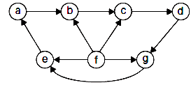 | CO4 | (06)
 | c) | Construct a 2-3 tree for the list [C,O,M,P,U,T,I,N,G]. Use alphabetical order of letters and insert them successively starting with the empty tree. | CO4 | (08)
8. | a) | Apply insertion sort to sort the list [89,45,68,90,29,34,17] | CO4 | (05)
 | b) | Find J(40)-the solution to the Josephus problem for n=40 using all the three methods. | CO1 | (05)
 | c) | What is an AVL tree? Explain the need for rotation of AVL tree. Construct an AVL for the list [10,20,30,25,27,7,4] by successive insertion | CO4 | (10)
 |  | UNIT- V
9. | a) | Define the following with an example.  (i) P Problem (ii) Non deterministic algorithm (iii) NP Problem (iv) Polynomially reducible problem (v) NP-complete problem. | CO5 | (10)
 | b) | Find the shortest tour of traveling sales person for the following cost matrix using branch and bound technique. Start the algorithm at the first city, assuming that the cities are numbered from 1 to 5. | CO4 | (10)
  0 | 14 | 4 | 10 | ∞
  14 | 0 | 5 | 8 | 7
  4 | 5 | 0 | 9 | 16
  10 | 8 | 9 | 0 | 32
  ∞ | 7 | 16 | 32 | 0
10. | a) | Apply nearest neighbor algorithm and solve the following traveling salesman problem.  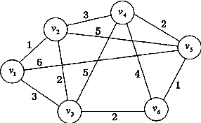 | CO4 | (08)
 | b) | Consider the Max Heap shown below as an initial heap, illustrate step wise pictorially where the value 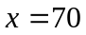 would be inserted into the given heap and also provide the pseudocode for the insertion operation in a max heap.  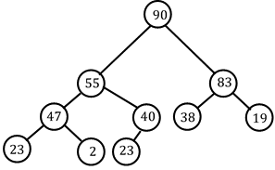 | CO4 | (06)
 | c) | Explain how backtracking can be used to solve n-Queen’s problem. Design the two solutions for 4-Queen’s problem. | CO5 | (06)
****************

